# DNA Replication

1. Explain the 3 main steps in the process of DNA replication. Name the enzymes that goes with each step
   1. Step 1
   2. Step 2
   3. Step 3
2. In which direction are new nucleotides added during replication?
3. Below is a single strand of DNA. Below each letter write the complementary strand of DNA

3` A - T – G – C – G – C – G – A – T – T – A – T – C – G – C 5`

1. From the double helix that you got in question 4, using 2 different colors, create 2 new strands from the original strand. Label which color represents the strand from original strand and which color represents the daughter strand.

# Mutations

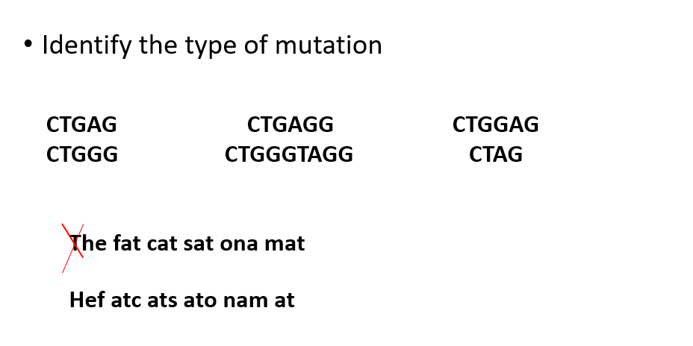

2. During our class lecture we learnt about how a gene is decoded to mRNA and to proteins. Sometimes there is a mutation, i.e., a change in a gene or genes. We saw an example of Progeria where a single base change affected mRNA splicing and hence resulted in altered protein products. In general, the mutation changes the gene's instructions for making a protein, so the protein does not work properly or is missing entirely. This can cause a medical condition called a genetic disorder.

3. Genetic disorders are of 3 types:

a. Single-gene disorders, where a mutation affects one gene.

b. Chromosomal disorders, where chromosomes (or parts of chromosomes) are missing or changed. Chromosomes are the structures that hold our genes. Down syndrome is a chromosomal disorder.

c. Complex disorders, where there are mutations in two or more genes. Often your lifestyle and environment also play a role. Colon cancer is an example.

For beginners, let us focus on single gene disorders.

Assignments:

1- Google and find a single gene disorder of interest to you.

2- Write a brief description of the disorder, say one or two sentences. You can write more if

you wish to.

3- Explain the disorder in terms of gene sequence and how it affects the transcription [to mRNA] or translation [to protein] process.

For reference, follow the Progeria example discussed in the class.